**Project Proposal**

**CSIS-3275 Software Engineering**

**(Dr. Caesar Jude Clemente)**



**Providence Wealth Advisory**

Stephen Joy - 300329148

Yash Chawla - 300329318

Nguyen Tran - 300323900

Rupinder Kaur-300338246

**Table of Contents**

Business Case 3

Problem or Issue Statement 4

Revenue Model 6

Functional Requirements 7

Non-Functional Requirements 8

Use Case Diagrams 9

# Business Case

The hype around non-fungible tokens (NFTs) continues. Even though it is mainly happening within the crypto bubble, a closer look reveals a huge potential for the real economy. NFTs will open up new types of marketplaces and digital ecosystems unlike anything we have seen today. Therefore, it is good to understand the potential and then draw possible business conclusions from it.

With everything a person needs to keep track of in their day to day life, we know that the average person cannot keep track of the sudden changes that happen in the economy. This is where our service comes into play. It will help regular consumers connect with expert financial advisors and experienced investors to provide them with the knowledge required to invest in an ever-changing economy. The app will provide multiple ways of interaction such as text and video-based communication. The users will be able to schedule appointments with the advisor they choose for one on one video conferencing sessions. They will also be able to join scheduled seminars that will be conducted by a panel of select expert advisors. The app will offer membership plans for small businesses and start-ups that are looking for regular meeting and on-going support.

# Problem or Issue Statement

It takes money to make money. There are several ways to make money. One is trading your time for earning money, which is the slowest because you only have 24 hours in a day and no one expects you to work all of them since it requires a huge ton of effort on your part and it drains you mentally and physically. It doesn't require you to invest money for this particular approach, just some good marketing skills to sell yourself to the highest bidder.

The second method is to let your money work for you. This can occur even while you are sleeping and is, of course, a much more efficient method. This is the one that will cost you money. You invest that money, and if done right, the money you invested will make you more money, passively. To help you with this, there are many different businesses that offer you services that may help guide you to success. But nowadays with work and social life to balance, we don’t get enough time for anything else. Replying to texts messages and emails feels like a chore. Some of these services even provide you with expert opinions to help you with your investment, but every time you talk to a different expert and each one has a different opinion. Also, these services are known to sell your data to third party software giants to generate extra income breaching your right to privacy.

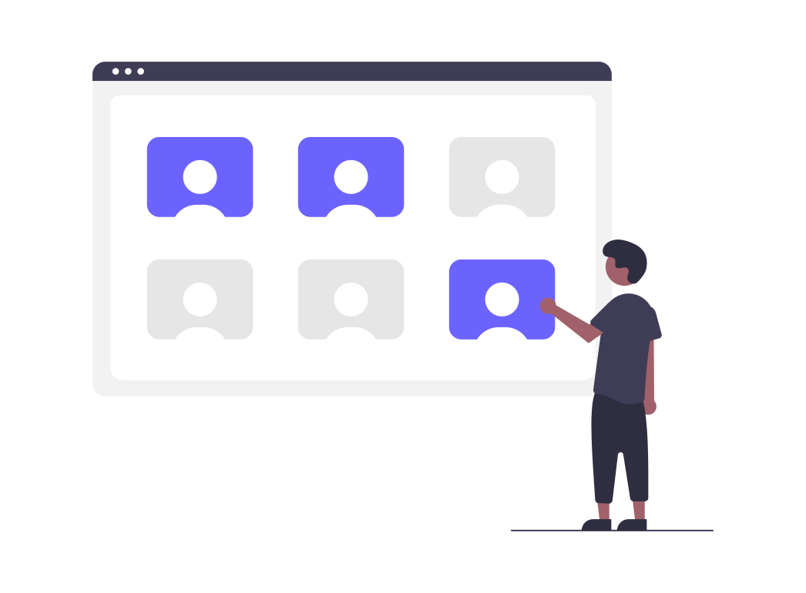

Our service will help you connect with an expert of your own choosing who will help you with your financial enquiries. We will offer different modes of communication such as text as well as one on one audio / video chats with the advisors for an interactive experience. This will allow you to communicate and address your concerns in real time as opposed to asynchronous means of communication.

# Revenue Model

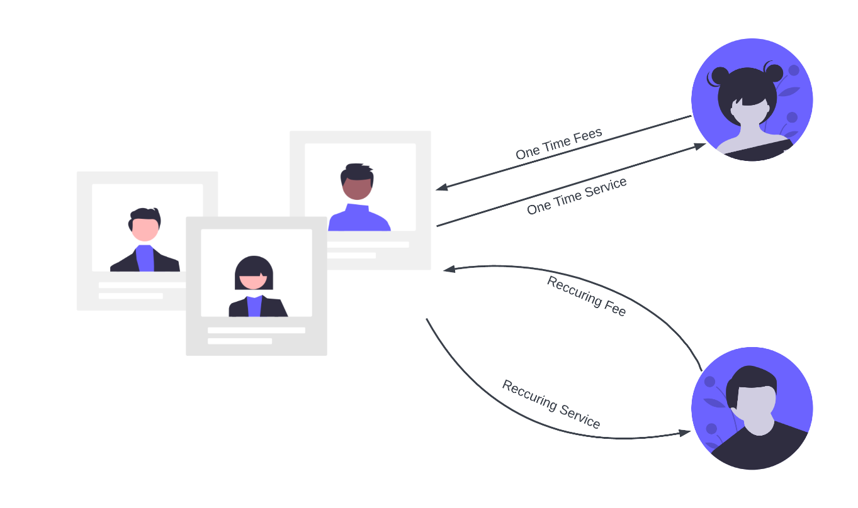

Figure 1 : Revenue Model

The revenue model we decided upon is a combination of **Recurring revenue model** where the customer pays for access to a product or service in instalments (usually monthly, quarterly or yearly) and **Service revenue model** where the customer pays for the time or expertise. In terms of Recurring revenue model, the customers will be given an option to subscribe to a monthly (1 month, 3 months, 6 months) or yearly subscription service which will provide the user access to a limited number of sessions according to their liking. The Service based revenue model will be applicable to users who want to use the service on their own accord.

# 

# Functional Requirements

* The website should provide a landing page displaying services and membership fees.
* Users should be able to sign up and login securely.
* A feature to provide the user with a questionnaire to find out their particular interest in investment during signup.
* They should be able to manage their profile.
* A dashboard showing the amount of time consumed in communicating, and remaining time.
* They should be recommended a list of Experts based on how they answered the questionnaire, and also based on ratings provided by the community.
* Ability to look up particular experts.
* They should be able to select a membership plan based on their usage or will be given an option to pay as they go.
* They should be able to communicate with the expert of their choosing via Audio / Video conferencing and chat.
* The sessions should be recorded for later review in case of conflicts of interests or negative feedback.
* They should be able to provide feedback regarding the session.

# 

# Non-Functional Requirements

* **Usability**: The app should be easy to use with clear signage and be easier to navigate between different sections.
* **Availability**: The web app should be made available to access by the user at all times.
* **Security**: Certain parts of the web app should be accessible by the user only when they have been authenticated. All Personally Identifiable Information (PII) should be stored securely using encryption to protect user privacy.
* **Capacity:** The app should be flexible enough to adapt to sudden increase in the number of transactions per second.
* **Reliability:** The web app should not crash under heavy load, incorrect inputs and should behave similarly every single time.
* **Compatibility:** Compatibility with a wide variety of devices is expected since this is a web app.
* **Serviceability:** Experts should be available according to their specified timeslot. Members should be given the option to arrange off-hours meetings with experts if required.

# Use Case Diagrams

Use Case Diagram


Figure 2 : Use Case Diagram